4.1.)

A) Characteristics of coaxial cable:

a.) diameter [mm]:

- External diameter size:

- Thin coaxial cable: 5 mm

- Thick coaxial cable: 25 mm (thick dielectric insulator)

b.) list of connector types:

* + BNC – Bayonet Neill-Concelman
  + N-Type connectors
  + TNC - Threaded Neill-Concelman
  + F- type connectors
  + QMA connectors

c.) length of connector (coupler) to NIC [mm]:

* + BNC – Bayonet Neill-Concelman -------------25mm
  + N-Type connectors-------------------------------28mm
  + TNC - Threaded Neill-Concelman-------------28mm
  + F- type connectors-------------------------------18mm
  + QMA connectors---------------------------------20mm

B) Characteristics of twisted-pair cable:

a.) diameter [mm]:

Wire diameter of about 0.4-0.8mm

b.) list of connector components

* PVC insulator
* Copper conductors
* Twisted pair separator
* Jacket
* Strain relief boot

c.) length of plug to NIC [mm]:

It ranges from 21.5mm to 100,000mm

C) Characteristics of optical fiber cable:

a.) diameter of outer plastic jacket [mm]: 2.2mm

b.) list of cable types according to length in increasing order:

* + Single mode fiber: Typically used for distances exceeding 10 kilometers and can reach up to 100 kilometers without regeneration.
  + Multi-mode fiber: Used for distances up to 2 kilometers in LAN (Local Area Network) applications and up to 500 meters in premises cabling.

c.) diameter of plug (ceramic, metal) submodule [mm]:

LC (Lucent Connector) Connector – 1.25mm

SC (Standard Connector) Connector – 2.5mm

ST (Straight Tip) Connector – 2.5mm

FB (Fiber Connector) Connector – 2.5mm

4.2.)

A) On the basis of your mental calculation how many decibel values do correspond to the following power ratios (x)?

x = 12 in dBs:

12 = 3 . 4

9.5 + 12 = 21.5/2 = 10.75

x = 14 in dBs:

14 = 2 . 7

6 + 16.9 = 22.9//2 = 11.45

x = 16 in dBs:

16 = 2 . 8

6 + 18 = 24 = 12

B) On the basis of your mental calculation how many values of power ratio do correspond to the following decibels?

In the case of 13 dBs x = 19.95

In the case of -68 dBs x = 1.58e-7 =158 \* 10-9

In the case of -70 dBs x = 1e-7 =158 \* 10-9

4.3.)

A) The properties of the Oracle VM VirtualBox

- version number: 7.0

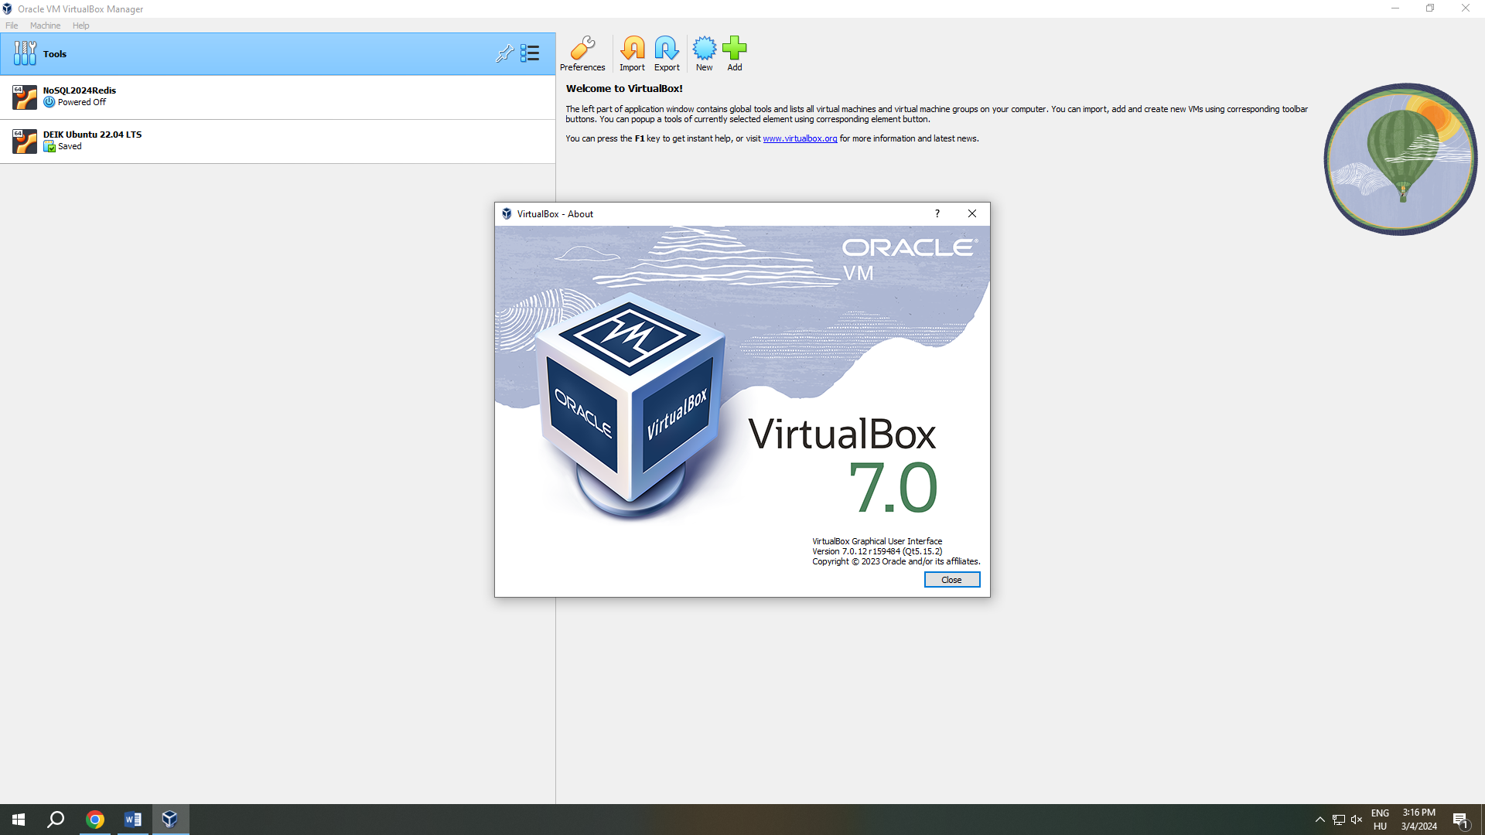

- number of possible VM types

6 although it can change

- possible types of VM network interfaces

* Network Address Translation(NAT)
* Bridged Networking
* Internal Networking
* Host only Networking
* Generic Networking
* Cloud Networking

- possible number of VM network interfaces

 Oracle VM Virtual Box provides up to eight virtual PCI Ethernet cards for each virtual machine. For each such card, you can individually select the following:

* The hardware that will be virtualized.
* The virtualization mode that the virtual card operates in, with respect to your physical networking hardware on the host.

B) The file structure properties of the Oracle VM VirtualBox

- relationship between the file structure of the VM and that of the host (paths)

In Oracle VM VirtualBox, a virtual machine and its settings are described in a virtual machine settings file in XML format. In addition, most virtual machines have one or more virtual hard disks. These are typically represented by disk images

* In the machine folder, a settings file: Example VM.vbox
* In the machine folder, a virtual disk image: Example VM.vdi.